I have chosen task 1 from the given list.

The execution begins with command “node app.js”.

All the required packages are also attached in project.

I have used local json files for storing data.

I have used “Postman” to invoke API’s, as shown in image below.

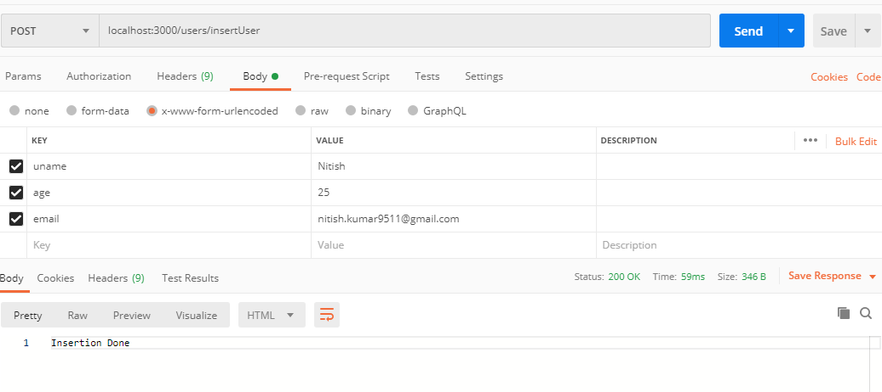

The API for creating a user is : localhost:3000/users/insertUser.